|  |  |  |  |  |  |
| --- | --- | --- | --- | --- | --- |
| Date | 29-Nov-22 | | | Tester Name | Shahabuddin Syed |
| Environment | Penfax - Test | | | Login used |  |
| Operating System | Windows | Version: | Update: | | |
| Software Used | Edge | Version: | Update: | | |
| Not Applicable | Version: | Update: | | |
| Release version | 22.4.1 | | | | |
| Title |  | | | | |
| Test Type | Regression | | | | |
| Test Scenario | Change an Employee's Employee Type | | | | |
|  |  | | | | |
| Expected Results |  | | | | |
| Pass/Fail | Pass | | | JIRA# | N/A |

Describe your steps with screenshots:

Need to search for a person in PEPP Penfax5 Test with Marital Status as Married, Plan as PEPP, Member Type as Employee, Member Status as Active, Gender as Male and Employer as "0050"

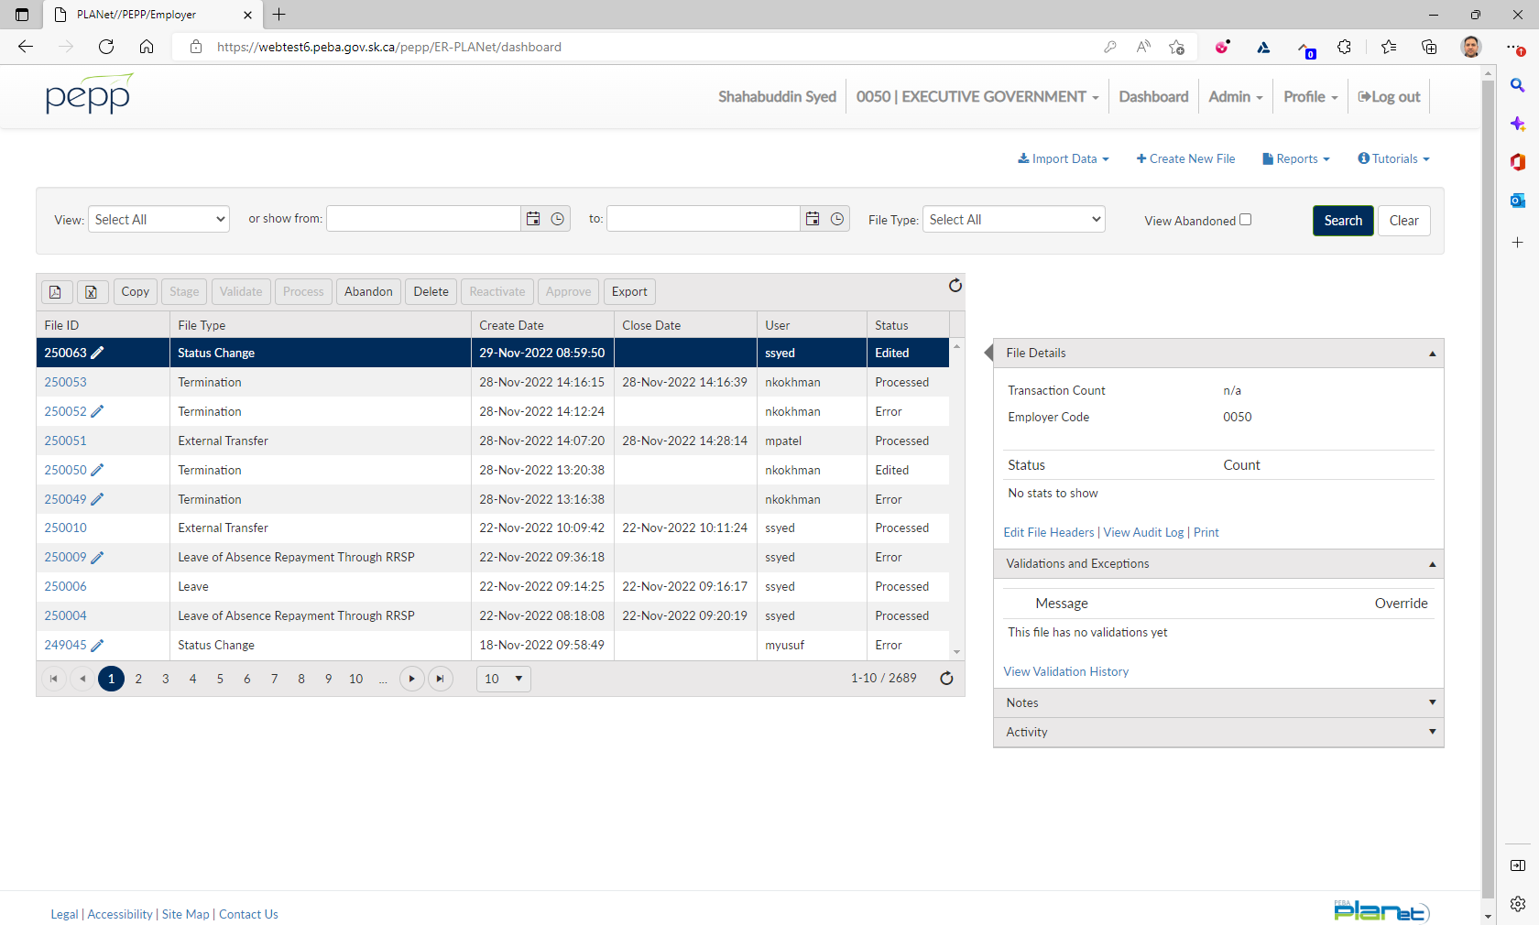

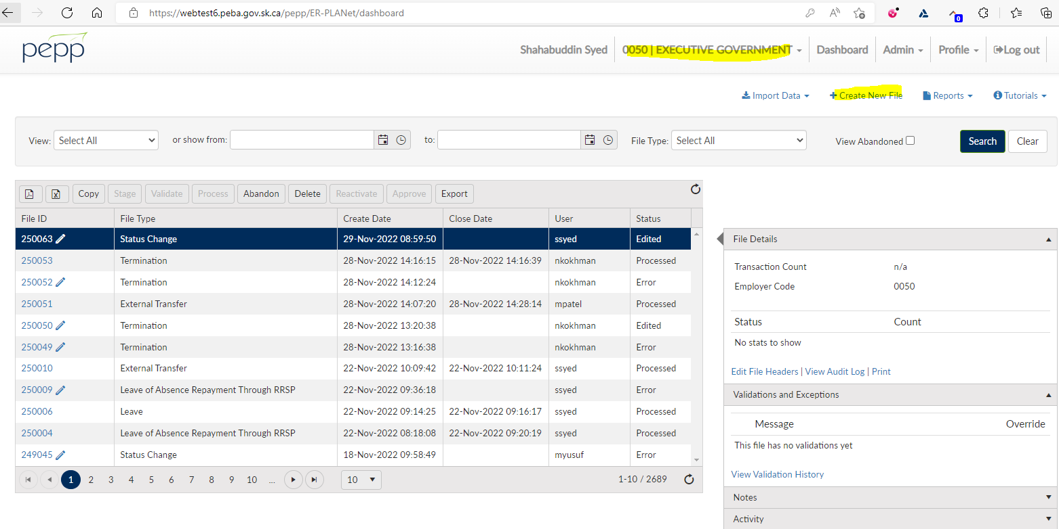

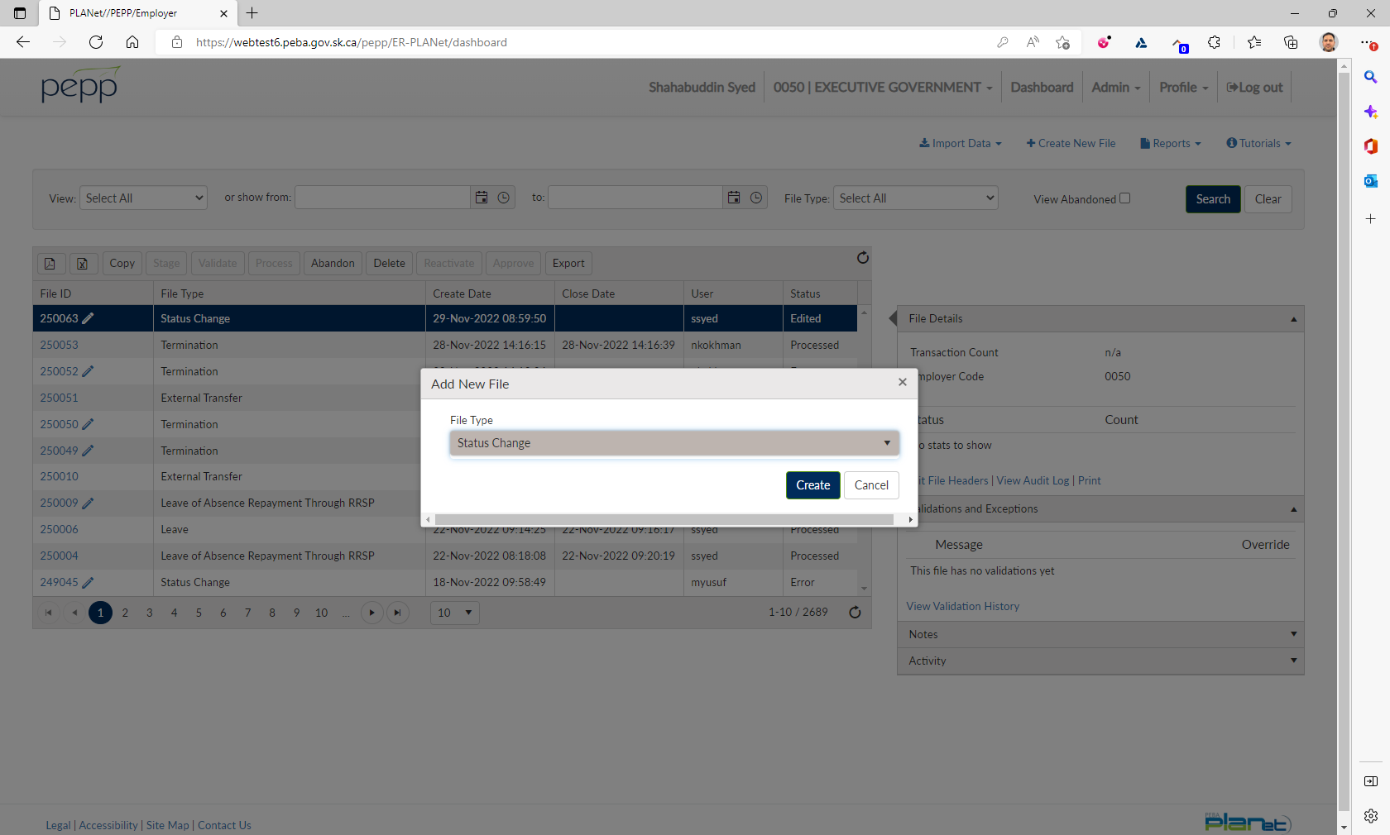

Click on File ID

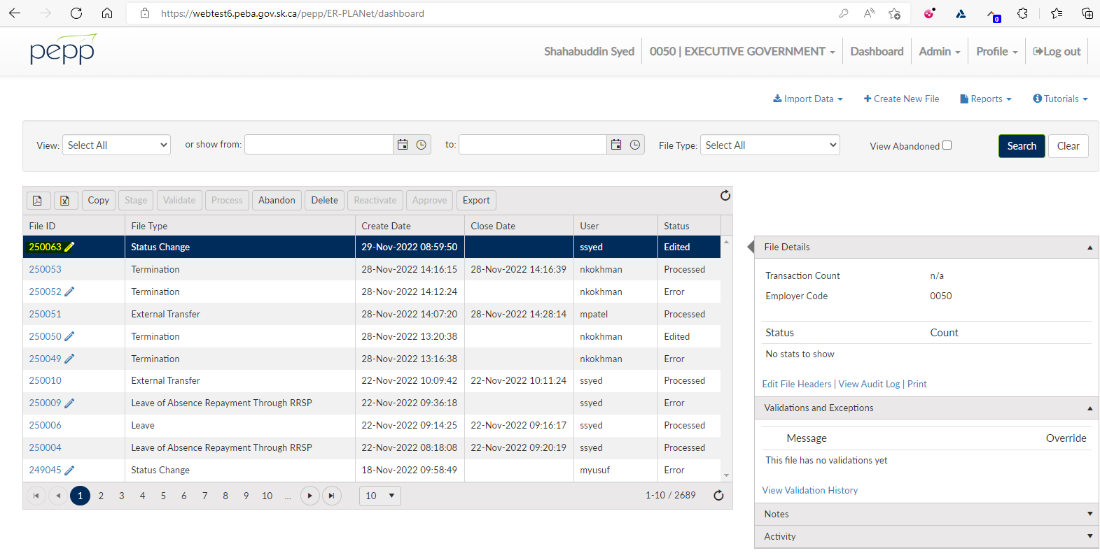

Click Add

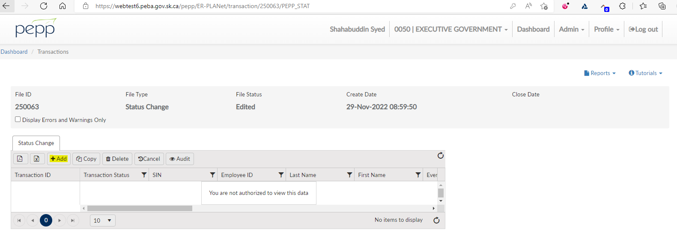

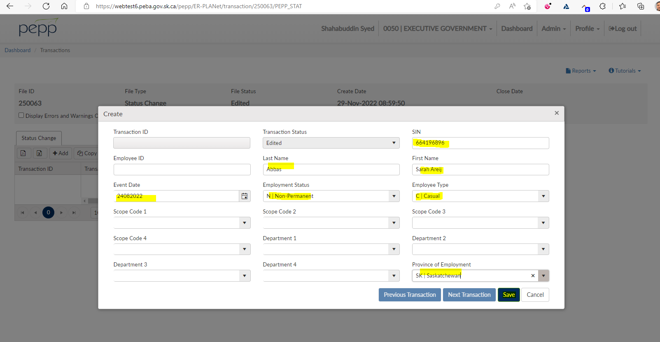

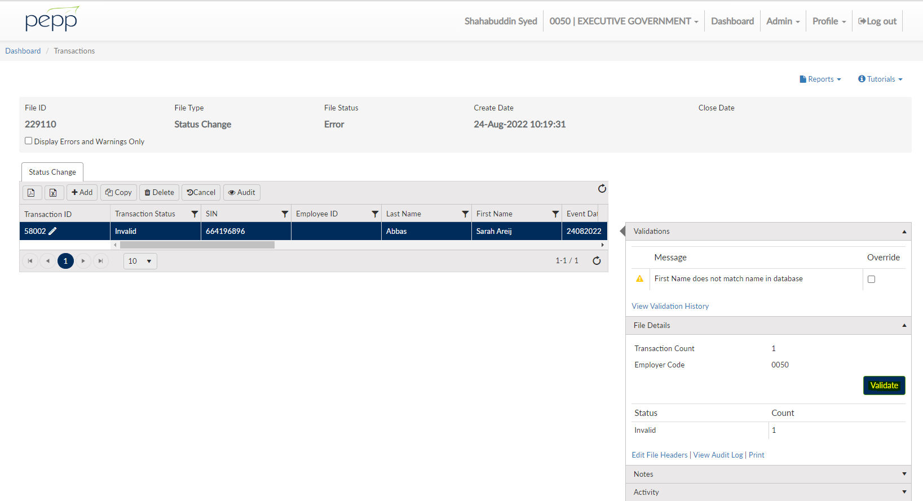

Click on Validate

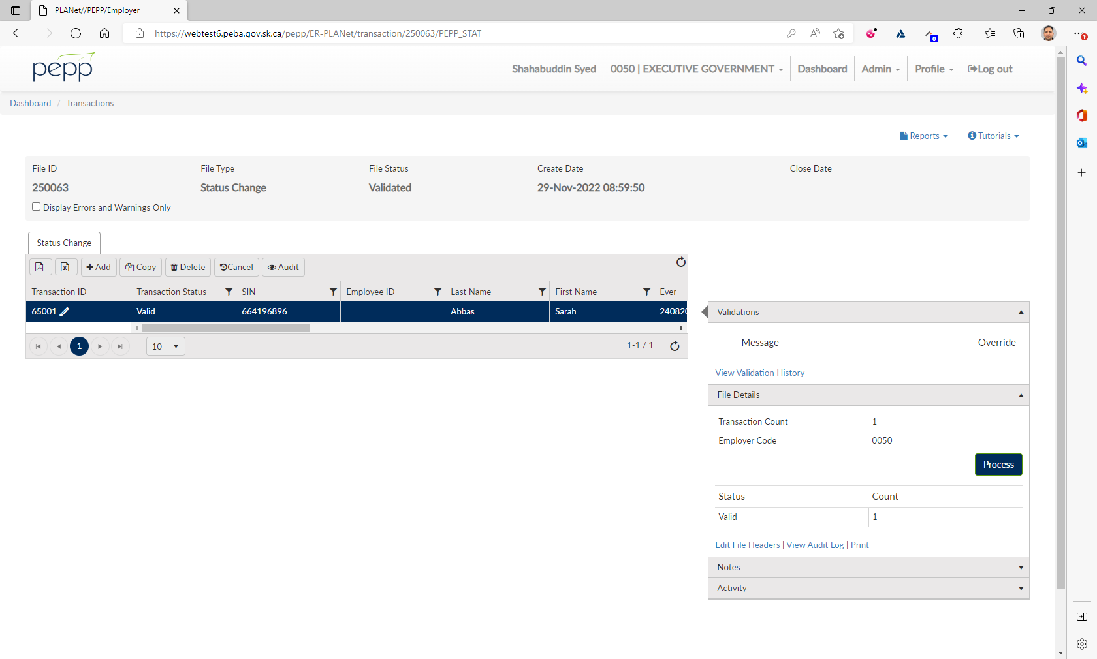

Click on Process

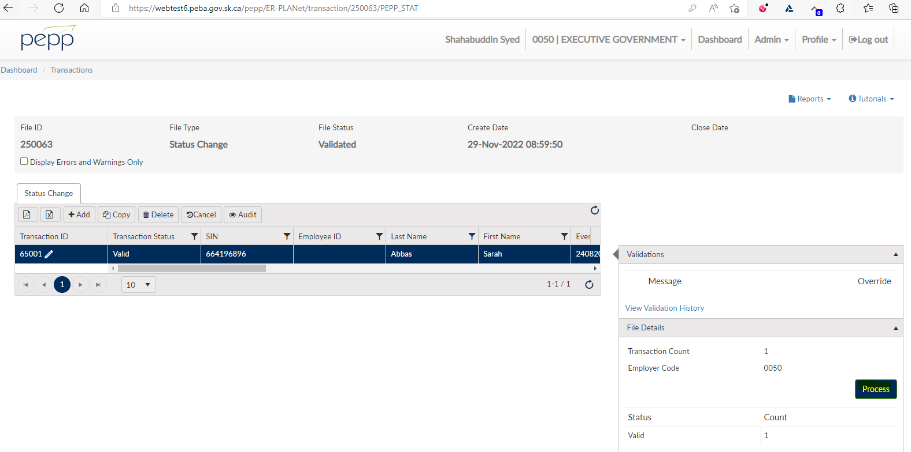

File Status shows as Processed

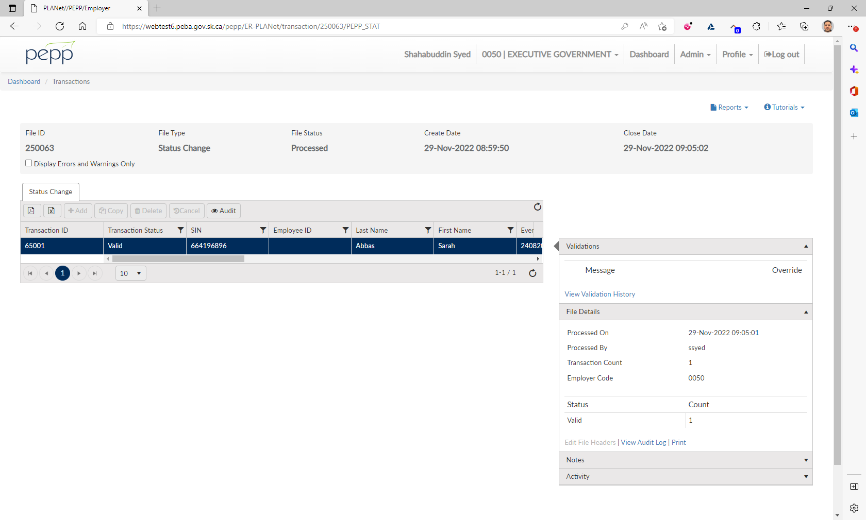

Need to verify in Penfax with the SID

Navigate to Person Profile 🡪 Employment Periods

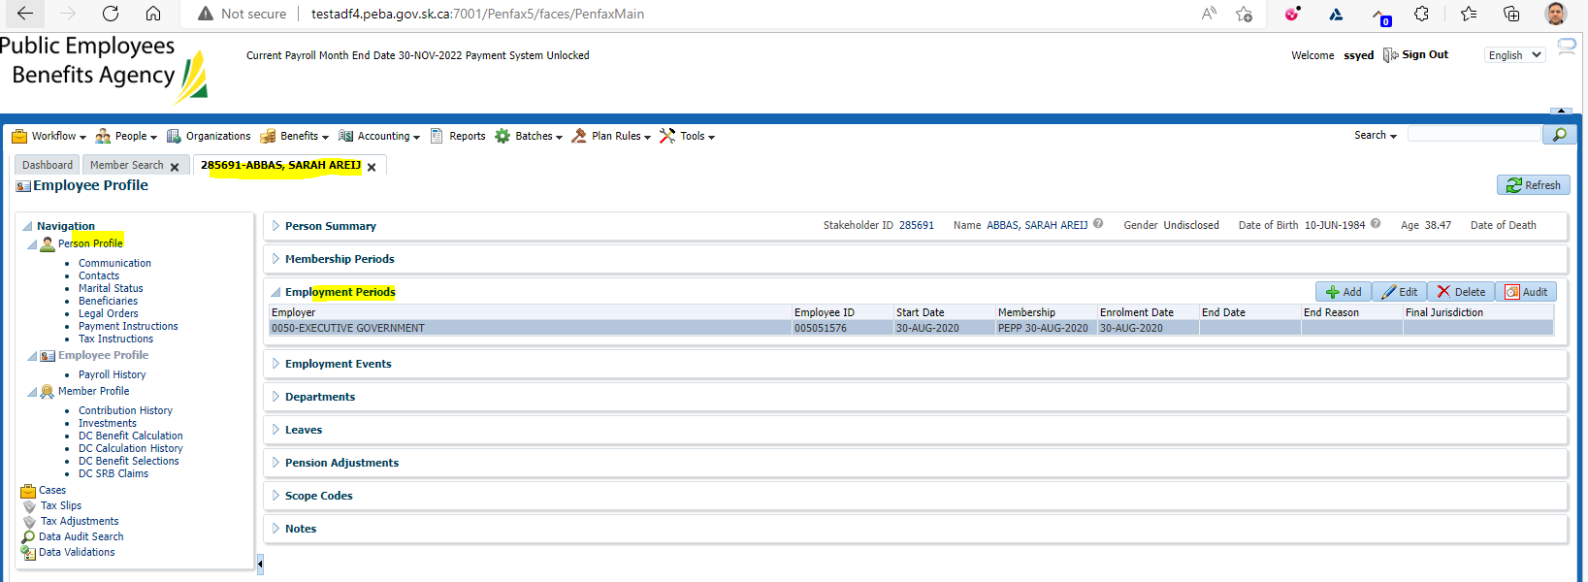

Need to go to Batches 🡪 Data Posting Batch

Status shows as Pending

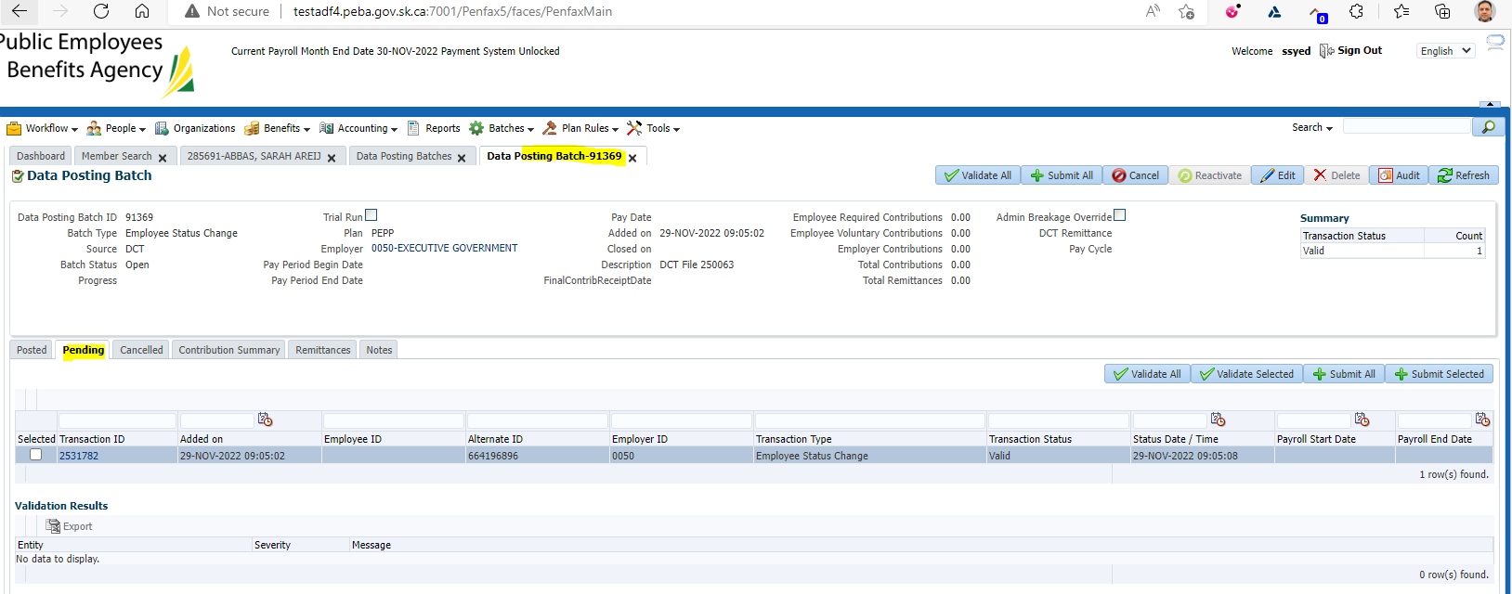

Need to click on Validate All

Then click on Submit All

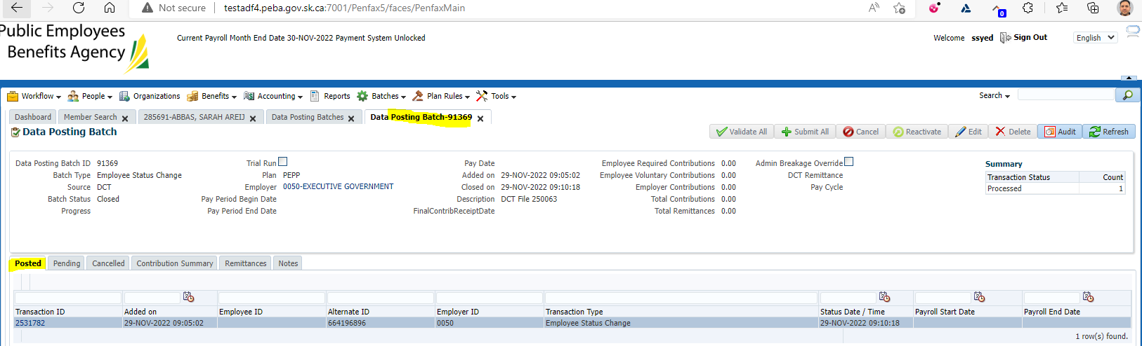

The batch would be posted

To validate the results, it now shows as Posted as it was in Pending status previously



Go to Employee Profile -- > Employment Events

The batch would be posted with the Employment Status

